Cisco DevNet Associate Cert Prep 1: Software Development and Design
Eric Chou

Section 2. Common Data Formats and Python

About accessing NX-API Developer Sandbox for the latest files

The example uses files retrieved from the Cisco DevNet Nexus Developer Sandbox. If you’d like to access the latest version of the documents used, the device can be access via any standard web browser without registration.

- Point the browser to https://sbx-nxos-mgmt.cisco.com. If you receive a warning for self-signed certificate, it is ok to proceed with the ‘advanced’ button then ‘proceed to sbx-nxos-mgmt.cisco.com’.

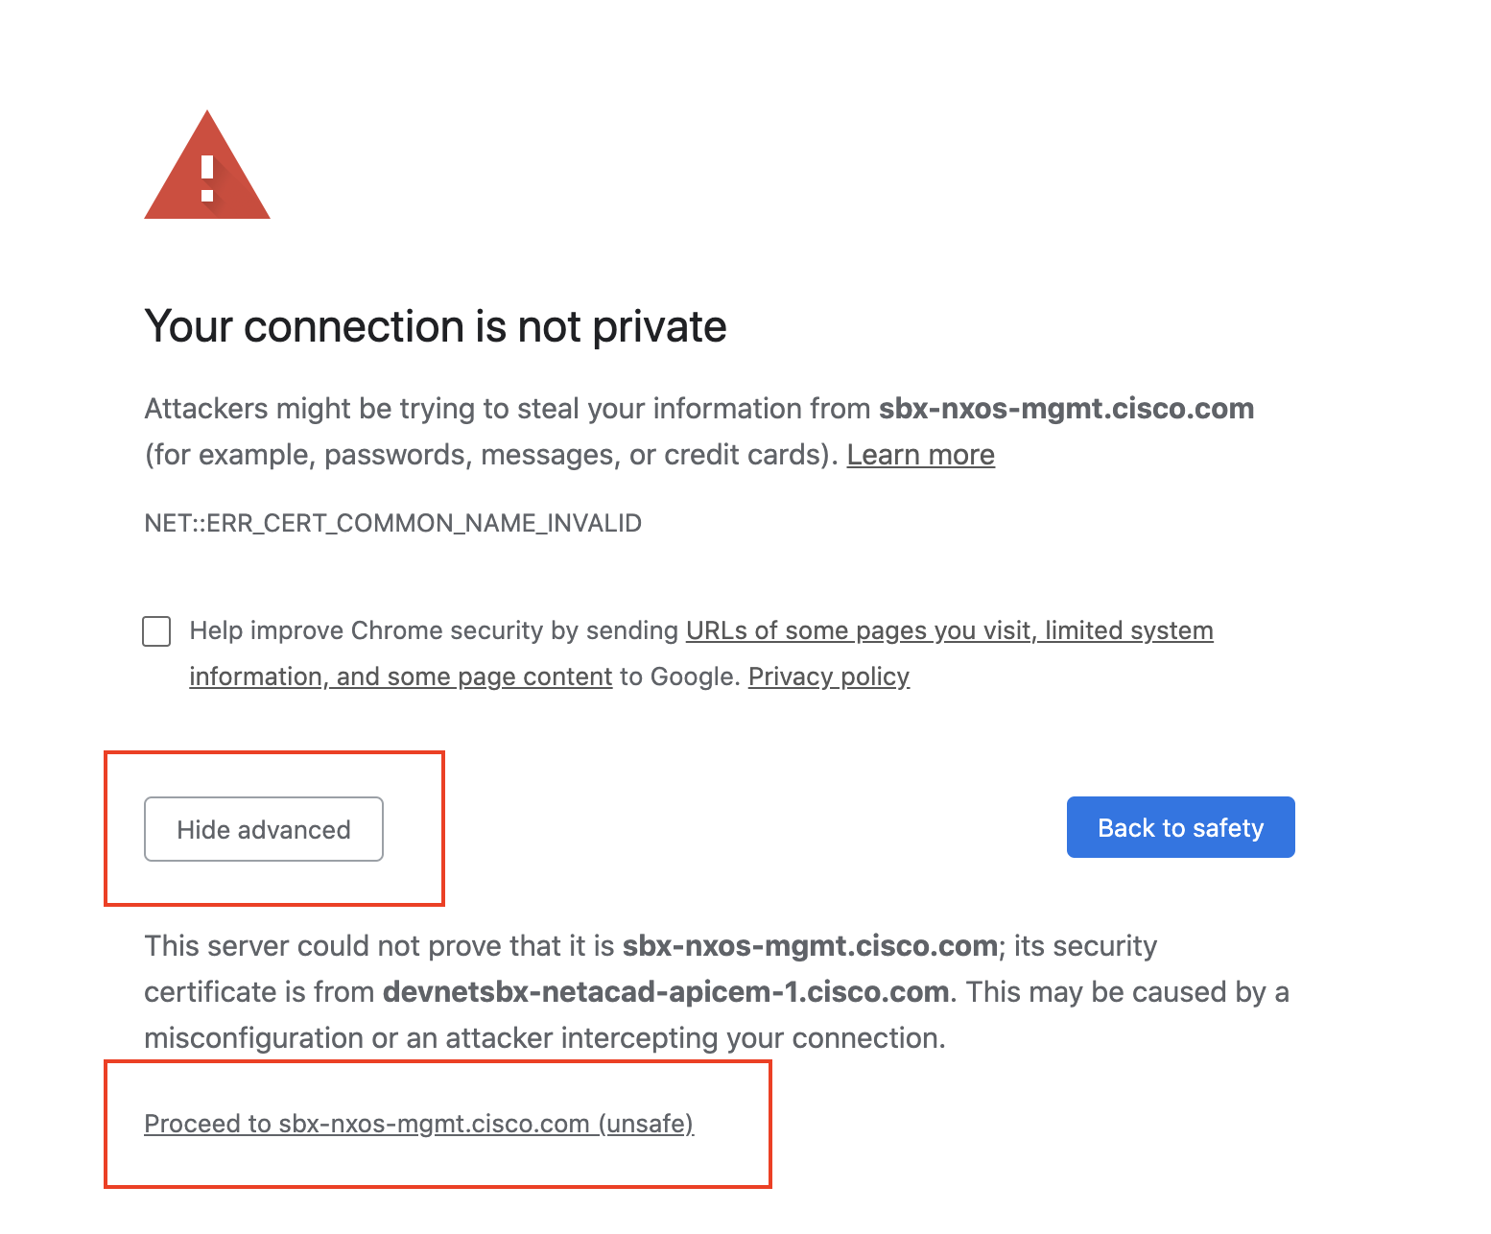

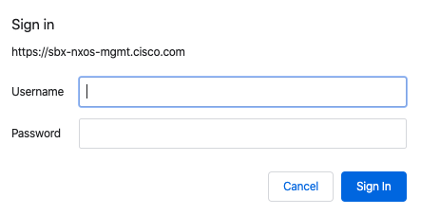

The username is ‘admin’ with password ‘Admin_1234!’ at the time of recording. Please check for the latest credential if needed, https://developer.cisco.com/docs/nx-os/#!nx-api-cli-developer-sandbox.

- The page should now be accessible.

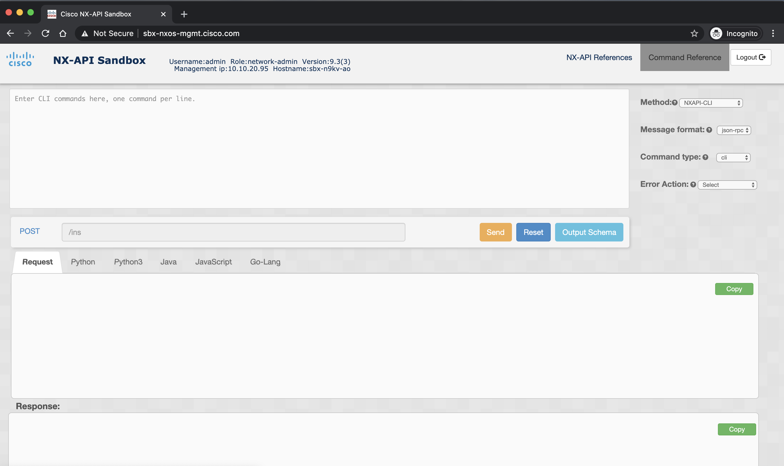

- Enter the appropriate command, pick the NXAPI-CLI as the method, and pick either XML or JSON as the message format.
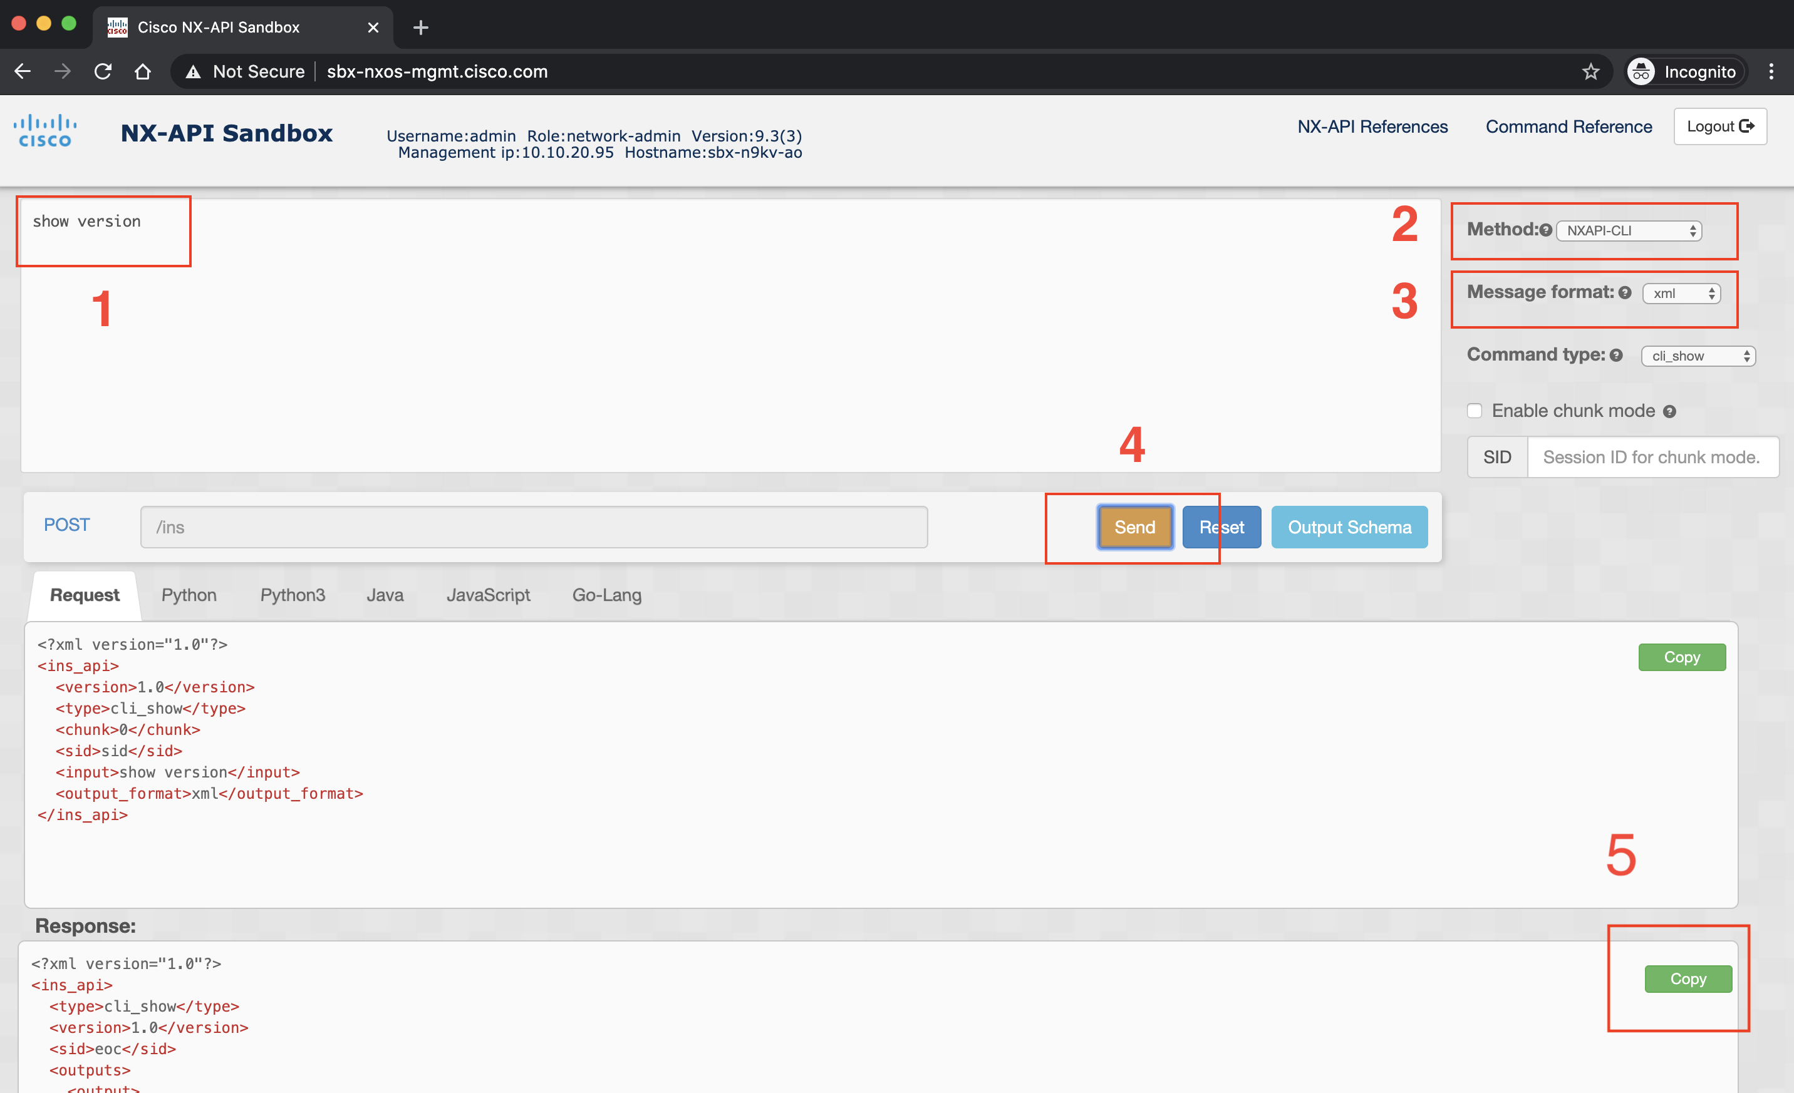

Documentation for Python Libraries Used in Section

- Python ElementTree Library Documentation
https://docs.python.org/3.8/library/xml.etree.elementtree.html

- Python JSON Library Documentation
https://docs.python.org/3/library/json.html

- Python PyYAML Library Documentaition
https://pyyaml.org/wiki/PyYAMLDocumentation

